Training manual:

Web System V1.0

04/19/2021

By Alexzander Ealy

**Contents**

Adding Links 3

Creating Filter 7

Testing Filter 7

Troubleshooting 12

Missing Link 12

Missing Filter 14

Missing Category 14

No Rate Selected 15

Invalid Filter 15

Removing Links 16

Removing links in bulk 19

Troubleshooting 19

Link not found 19

Link was unable to be removed 20

Modifying Links 20

Troubleshooting 21

Assigning Filters to Crawled Links 21

Troubleshooting 24

Adding Users 25

Troubleshooting 28

Removing Users 28

Removing Users in bulk 31

Troubleshooting 31

Modifying Users 31

Troubleshooting 33

Users and Categories 33

Assigning User to Categories 33

Unassigning Users from Categories 35

Troubleshooting 38

Looking up Items 39

# Adding Links

## How to Add a link

1. Double click on the application

You should be presented with a page that looks like:

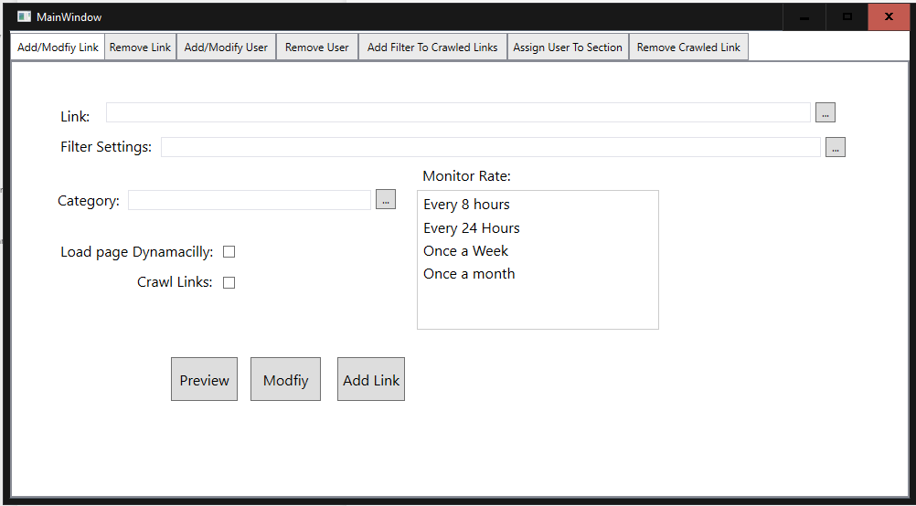

1. Enter the link you wish to add.

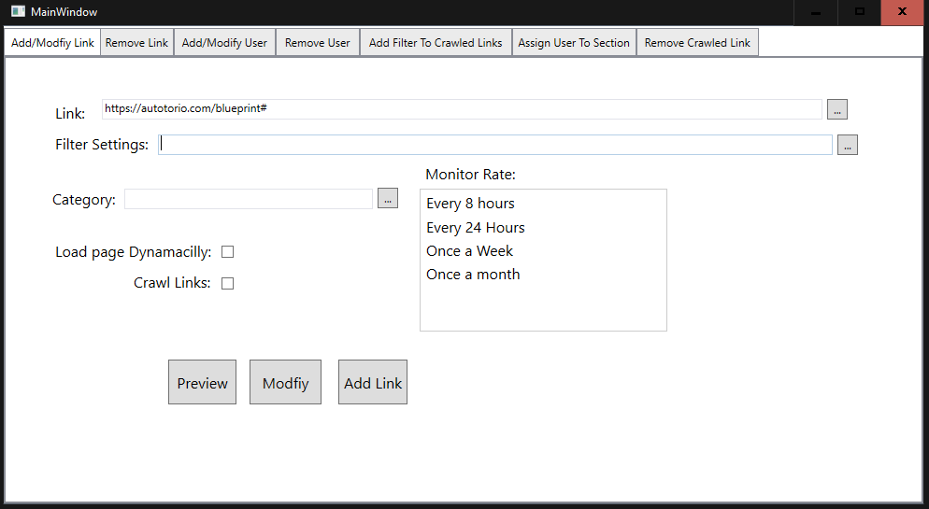

1. Enter a filter or click the “…” button to the right of the input box to use a previous filter. This will select an area of the page to be monitored.

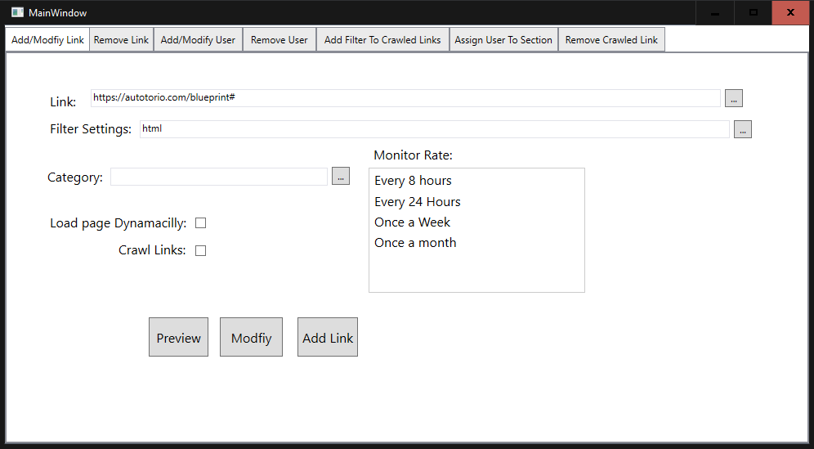

**Or**

Refer to Looking up Items section for a walkthrough on how to use the search function.

1. Enter a category or click the … button to the right of the input box to use a previous category.

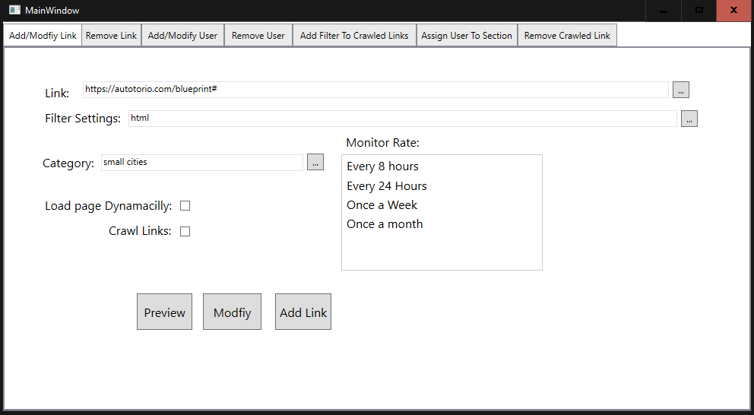

Note: If the Category is a new one then it will be created and added to the system upon successful completion of adding the link.

**Or**

Refer to Looking up Items section for a walkthrough on how to use the search function.

1. Select one of the four options in the box located under the words “Monitor Rate:” to set how often the page should be monitored.

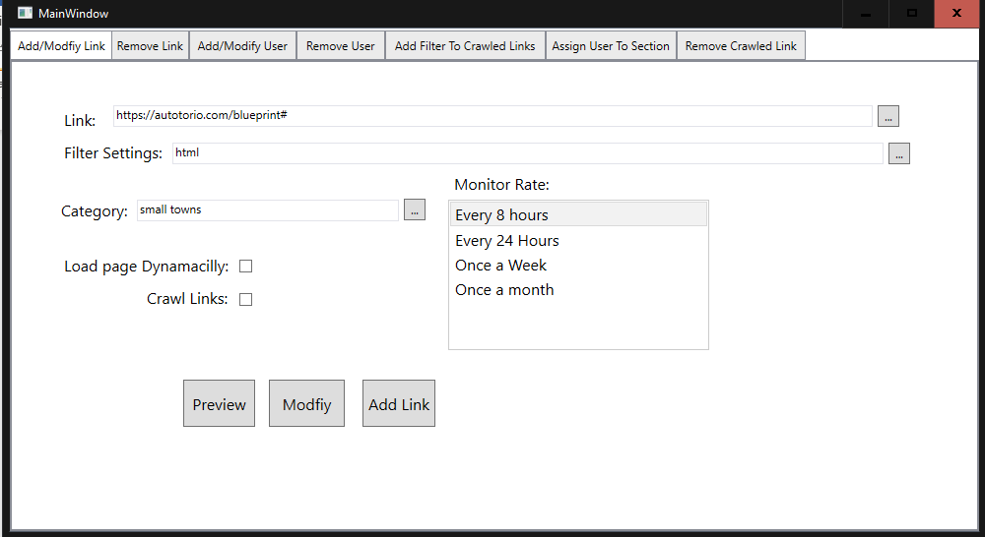

1. Check The box to the left to turn the option on.

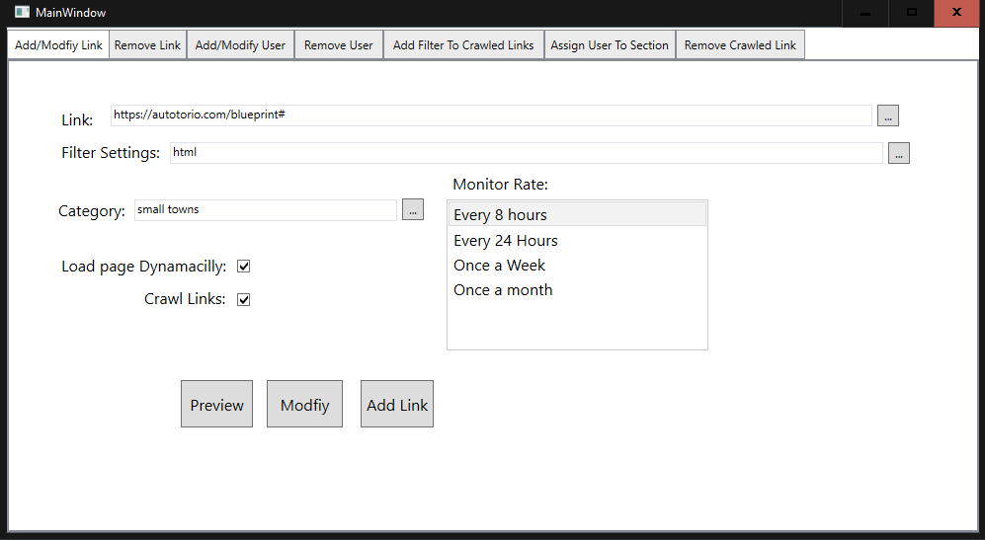

1. Click the “Add Link” button

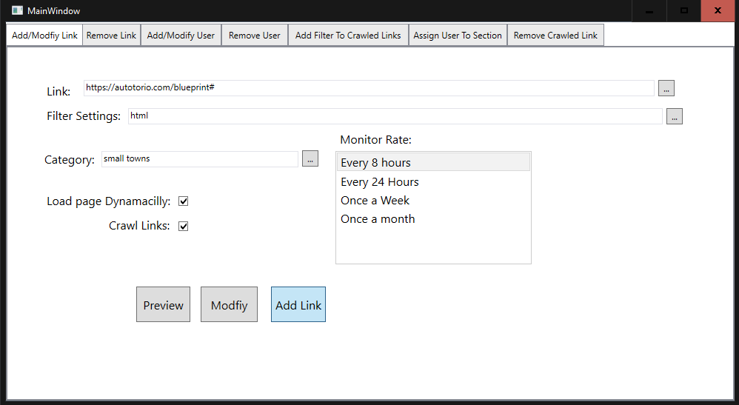

This means the link was added and assigned to the section.

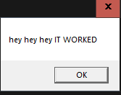

For an Error box refer to the Troubleshooting section for guidance on how to solve whatever problem that arises.

## Creating Filter

Refer to <https://facelessuser.github.io/soupsieve/selectors/> for documentation how filter creation.

## Testing Filter

1. Double click on the application

You should be presented with a page that looks like:



1. Enter the link you wish to add.



1. Enter a filter or click the “…” button to the right of the input box to use a previous filter. This will select an area of the page to be monitored.



**Or**

Refer to Looking up Items section for a walkthrough on how to use the search function.

1. Enter a category or click the … button to the right of the input box to use a previous category.



Note: If the Category is a new one then it will be created and added to the system upon successful completion of adding the link.

**Or**

Refer to Looking up Items section for a walkthrough on how to use the search function.

1. Select one of the four options in the box located under the words “Monitor Rate:” to set how often the page should be monitored.



1. Check The box to the left to turn the option on.



1. Click the “Preview” button

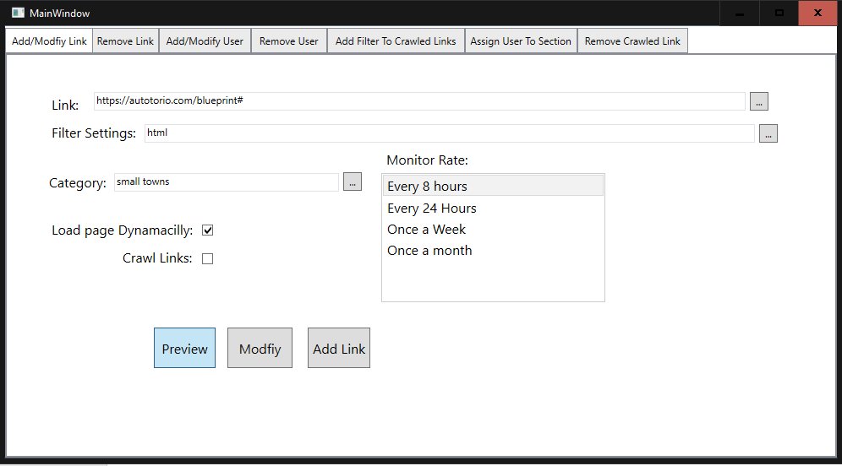

This window will pop up if the page was successfully filtered. Otherwise refer to Invalid Filter section for guidance.

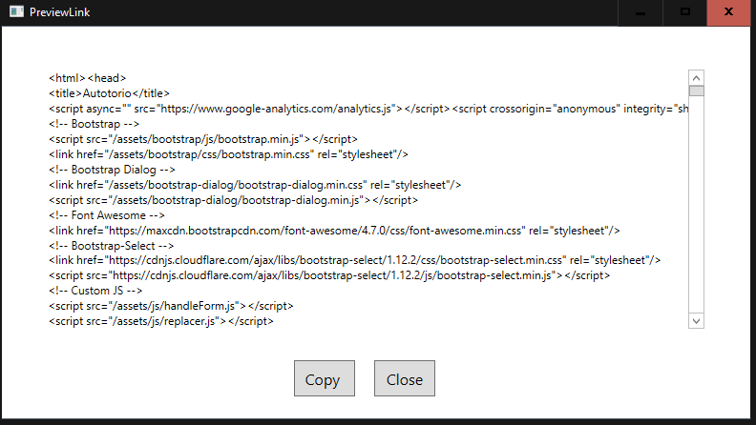

This shows you all the HTML code that was pulled and will be used to determine if the page changed. Clicking the “Copy” button will copy it all to the clipboard allowing for it to be pasted into an html generator to get a more visual representation.

## Troubleshooting

### Missing Link

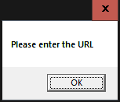

This error means you have not entered in a URL into the Textbox located to the right of the words “Link:”

Fill In the area surrounded in red below to solve error.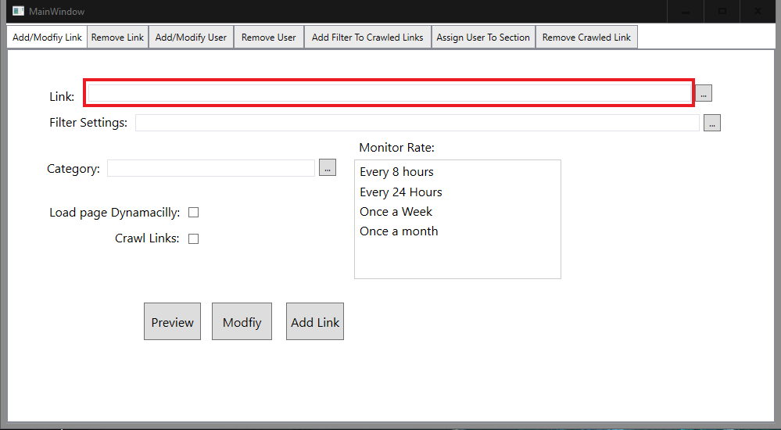

### Missing Filter

This error means you have not entered in a URL into the Textbox located to the right of the words “filter Settings:”

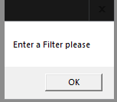

Fill In the area surrounded in red below to solve error.

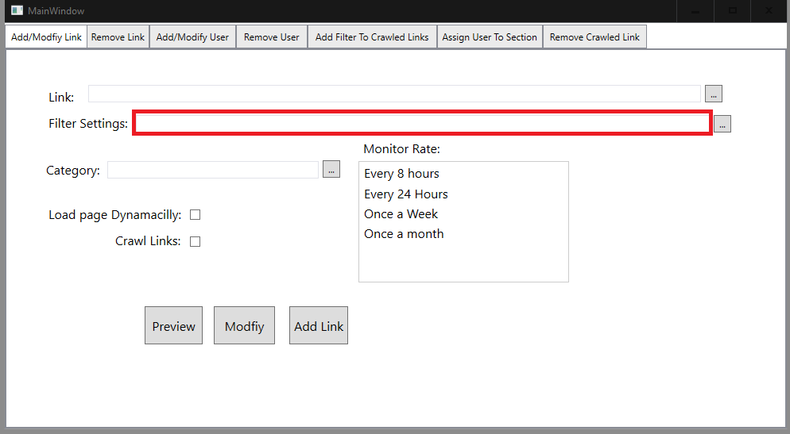

Note: To use a previous filter start to type in a new one then click the “…” button to get a list of similar filters.

### Missing Category

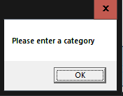

This error means the textbox to the right of the label “Category” is empty

Fill In the area surrounded in red below to solve error.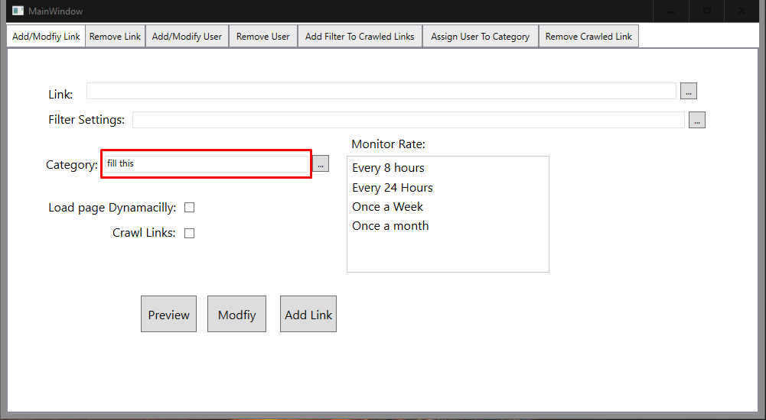

### No Rate Selected

This error means there was no option selected for how often the page should be monitored.

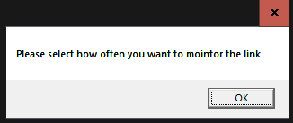

This error can be fix by selection one of the options in the list located under the label “Monitor Rate”

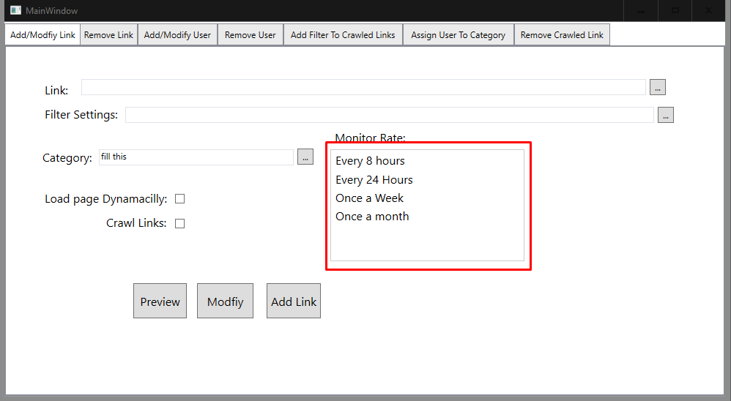

Note: just click on it to select the rate

### Invalid Filter/Link

This is error happens when the filter is valid but does not find any code and so if it was to be allowed users would never get notified about the website changes as it doesn’t monitor anything.

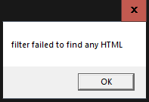

The fix is to either broaden the search criteria or reformate it in such away that it will pick up html off the website.

Change the textbox in red.

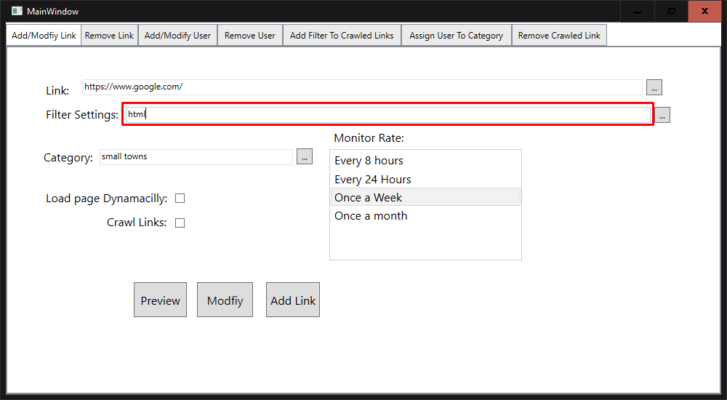

This error appears when either the filter is not valid because it would cause the system to crash if allowed to pass, or link is not valid.

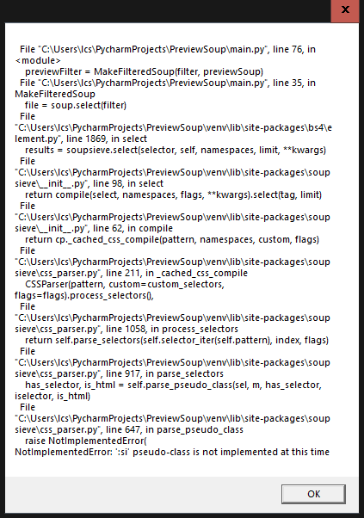

The key to telling which one it causing the issue is to read the last 5 or so lines of the error message, and then follow the instructions. For example, in this case the pseudo class :si is not a valid pseudo class hence it crashes and so the fix is to change :si to :is.

### Link is in system

This error happens when the link being added is already in the system.

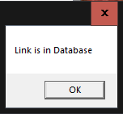

The fix is to either click the modify button if the values entered are the ones that should be assigned to the link or do not.

# Removing Links

## How to Remove Links

Note: To remove crawled links use the “Remove Crawled Link” tab and follow the same set of instructions below

1. Double click on the application

You should be presented with a page that looks like:



1. Click the “Remove Link” Tab at the top of the window

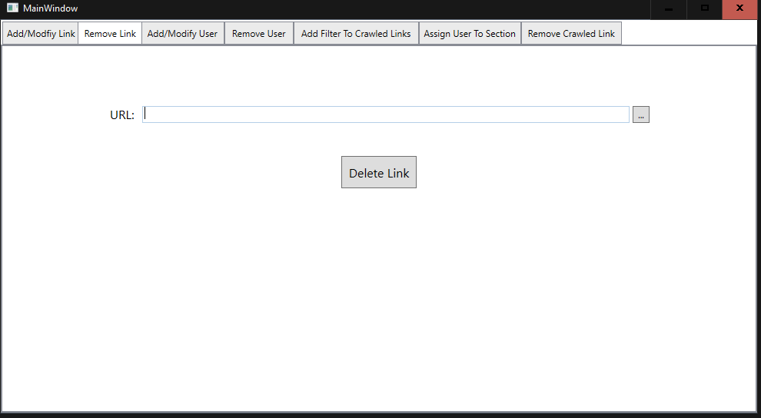

1. Enter the URL into the textbox or click “…” button

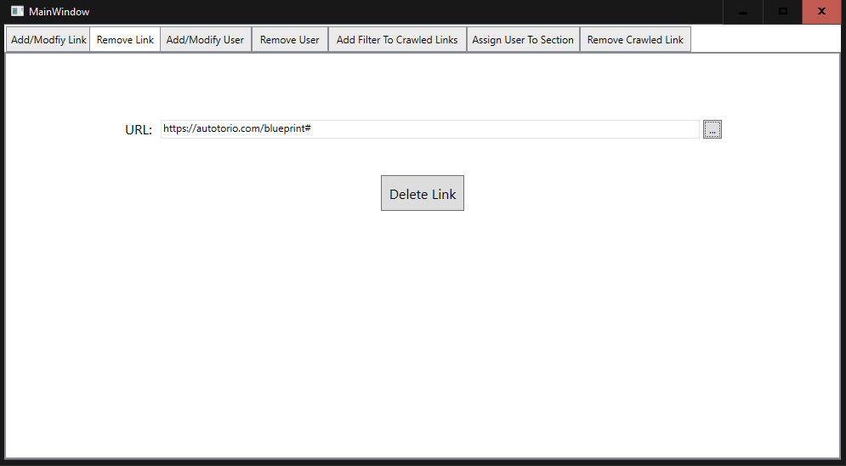

Note: refer to Looking up Items section for a walkthrough on how to use the search function.

1. Click “Delete Link” button

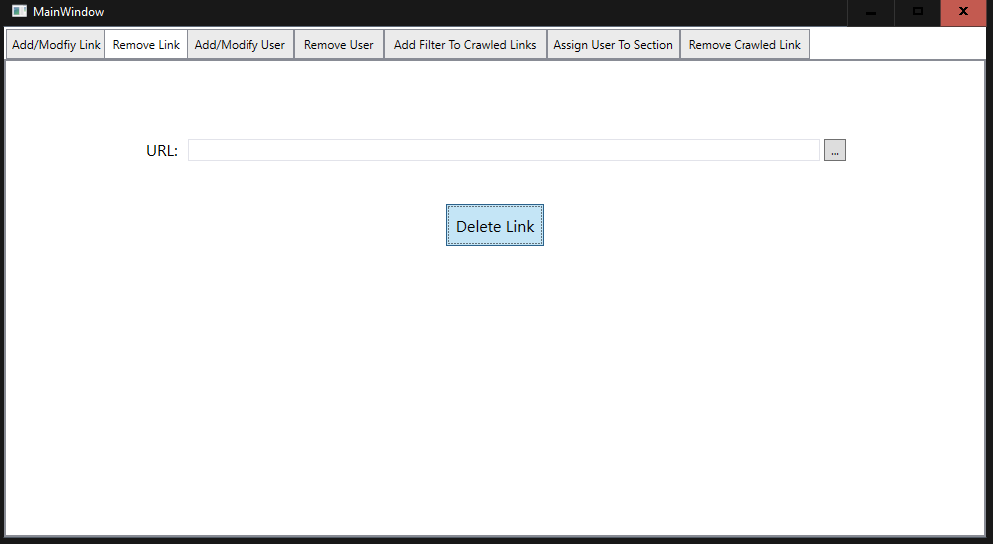

1. Click “Yes” to confirm removing the link

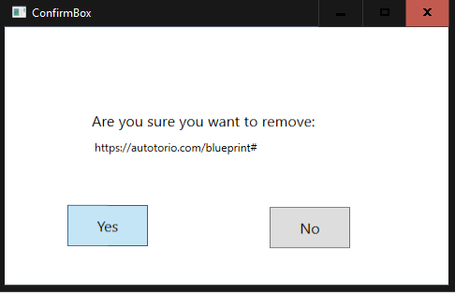

A box will pop up confirming the link was removed

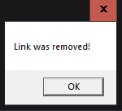

## Removing links in bulk

To remove links in bulk, go into the DBMS and create a query that deletes links based on their ID or whatever other method deemed fit by the DBA.

Note: Only the DBA should do this, and should only do this if there is a great surplus number of links to be removed, this should not be done by anyone who is not the DBA

## Troubleshooting

### Link not found

The error happens when a link is entered that is not in the database and so cant be deleted.

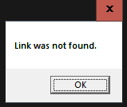

The fix is to ensure the link is spelt right, if not fix the spelling and try again, if the message still persists then the link doesn’t exist in the system.

### Link was unable to be removed

If this error happens, please report it to the DBA and have a C# specialist/SQL specialist come troubleshoot the problem as there is nothing the user can do to fix this error and should be impossible.

# Modifying Links

## How to modify a Link

1. Double click on the application

You should be presented with a page that looks like:



1. Use the search function to find the link to be modified

Note: refer to the Looking up Item section for guidance. It is strongly recommended to use the search function because it will automatically fill in the other boxes with the current values.

1. Edit any of the textboxes expect the link textbox
2. Click “Modify” button

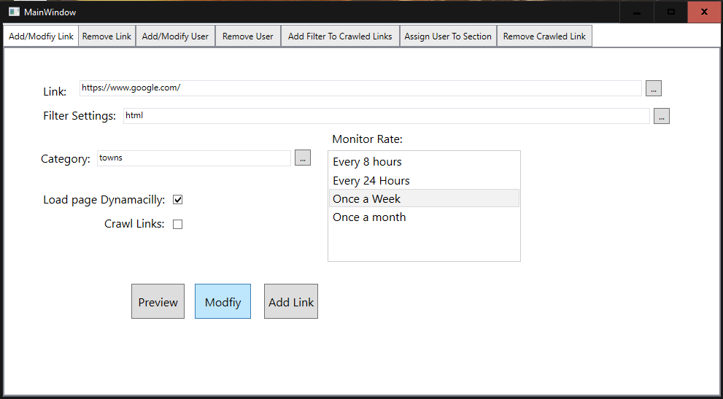

A window will pop up confirming the link was modified.

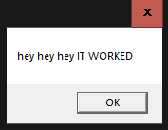

## Troubleshooting

### Link not found

The error happens when a link is entered that is not in the database and so cant be deleted.



The fix is to ensure the link is spelt right, if not fix the spelling and try again, if the message still persists then the link doesn’t exist in the system.

# Assigning Filters to Crawled Links

## How to Assign Filter to Crawled Links

1. Double click on the application

You should be presented with a page that looks like:



1. Go to the “Add Filter To Crawled Links”
2. Enter the link into the textbox that is to the right of the “Link:” label or, use the search function. Refer to Looking up Items section for help with the search function.

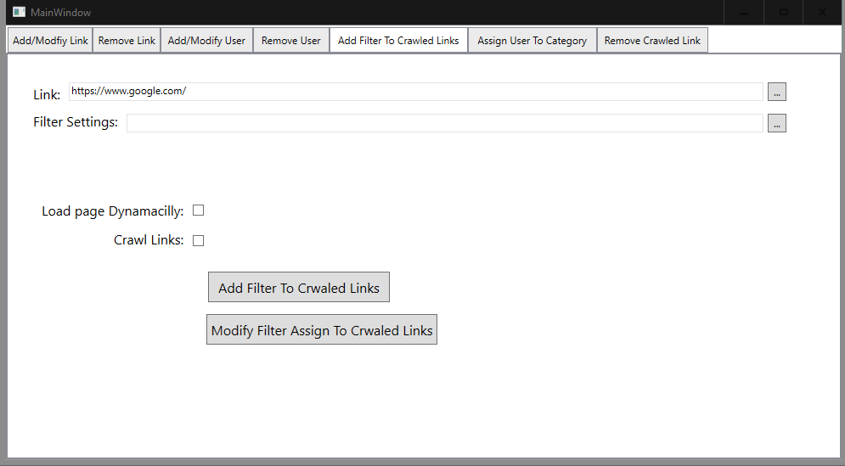

1. Enter in a valid filter into the textbox that is to the right of the “Filter Settings:” label or, use the search function. Refer to Looking up Items section for help with the search function.

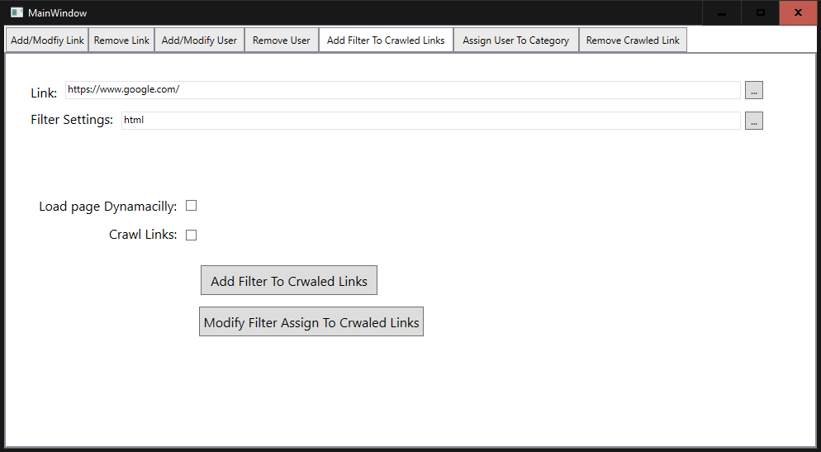

1. Check The box to the left to turn the option on.

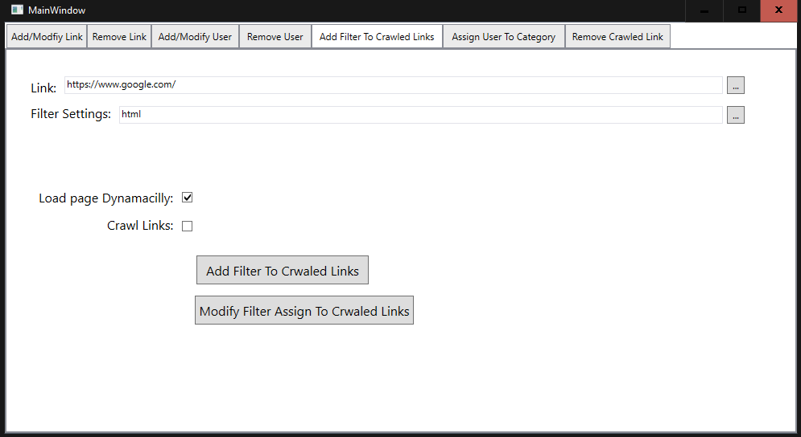

1. Click the “Add Filter To Crawled Links

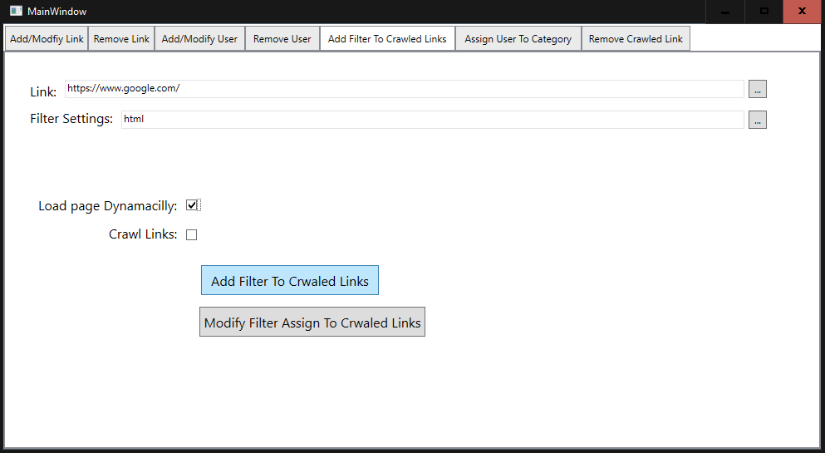

This window will pop up confirming the filter was assigned to the link

## Troubleshooting

### Filter already assigned

This error happens when trying to add a filter to crawled links when the crawled links already have a filter

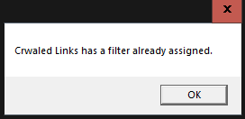

The fix is to click the modify button to update the filter assigned to the crawled links

### No filter found

This is intended and not an error, this message is just notify you that the link does not have a filter assigned to its crawled links.

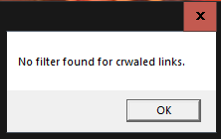

### Filter not assigned

This error happens when trying to modify a filter but the crawled links do not have a filter

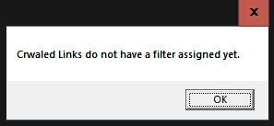

The fix is to click the “Add filter to crawled Links” button.

# Adding Users

## How to add Users

1. Double click on the application

You should be presented with a page that looks like:



1. Go to the “Add/Modify User” tab

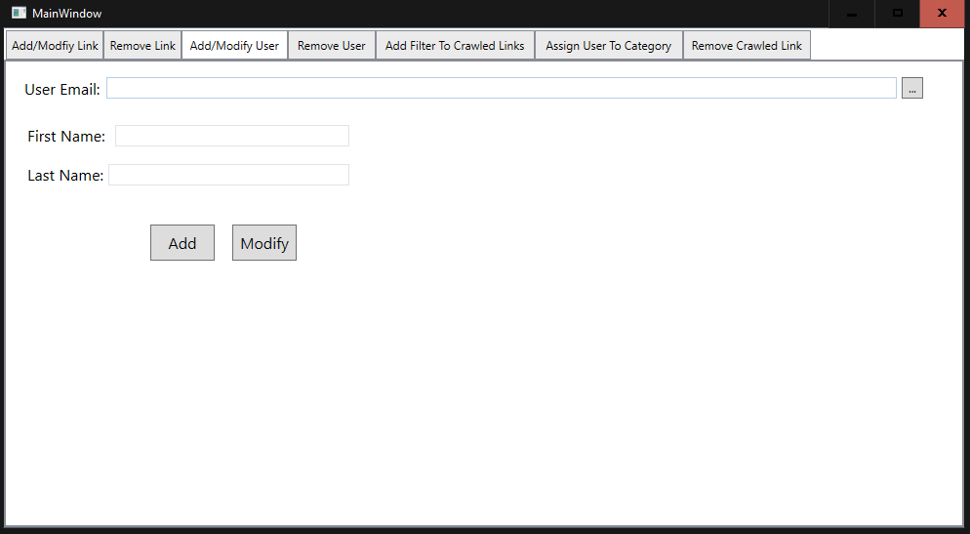

1. Enter in an email into the textbox

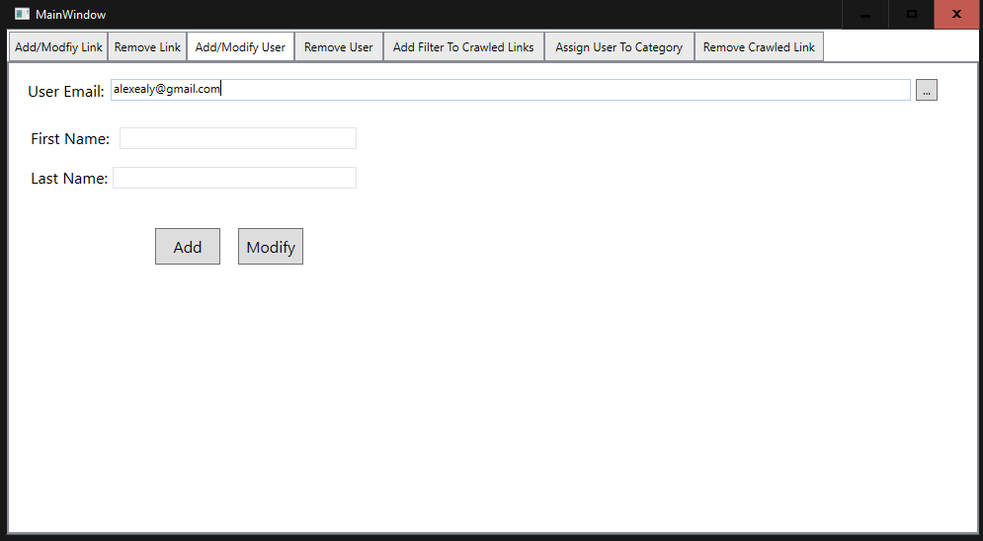

1. Enter in the user’s first name

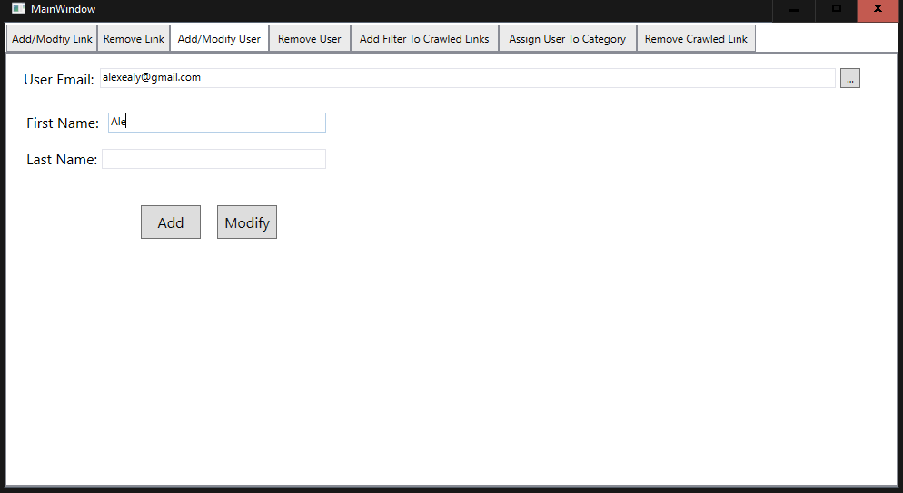

1. Enter in the users last name

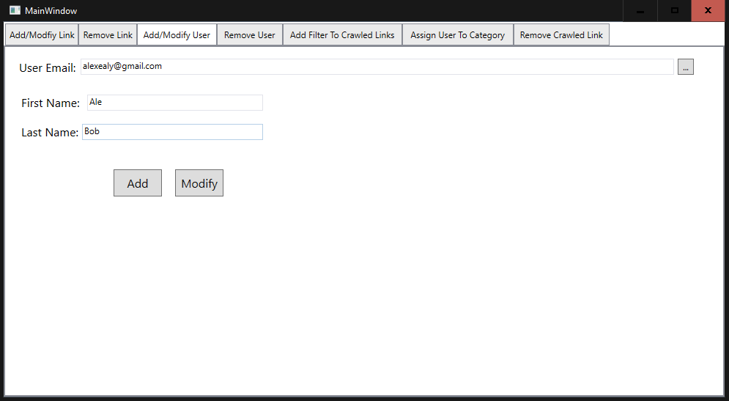

1. Click the “Add” button

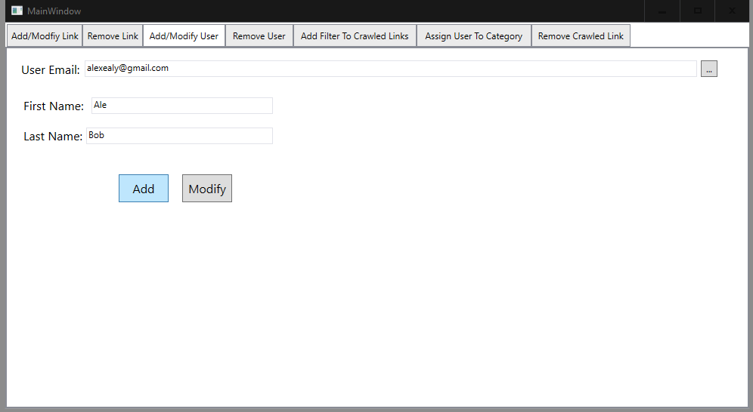

## Troubleshooting

### User in the system

This means user cannot be added because they are already in the system

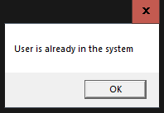

Use the modify to edit the values of the user.

# Removing Users

## How to Remove Users

1. Double click on the application

You should be presented with a page that looks like:



1. Click the “Remove User” Tab at the top of the window

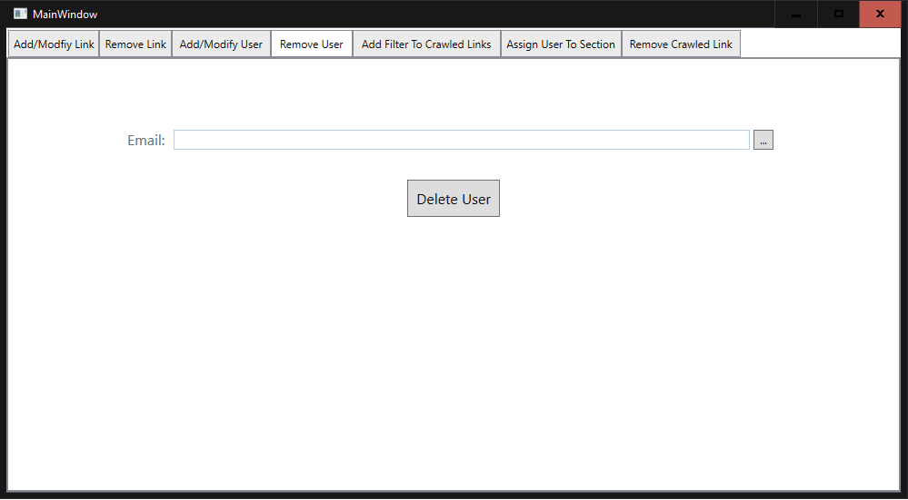

1. Enter the email of the user to be removed into the textbox or click “…” button

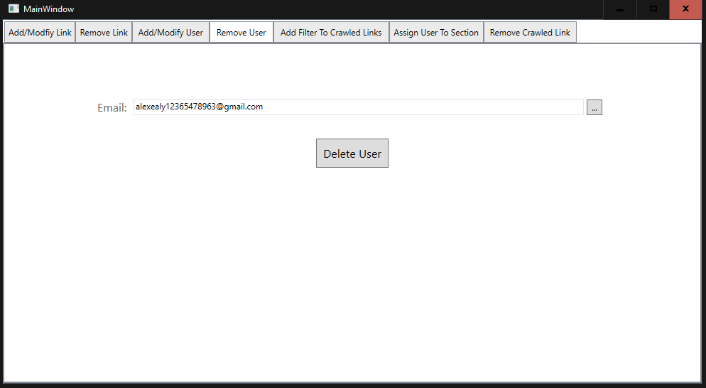

Note: refer to Looking up Items section for a walkthrough on how to use the search function.

1. Click “Delete User” button

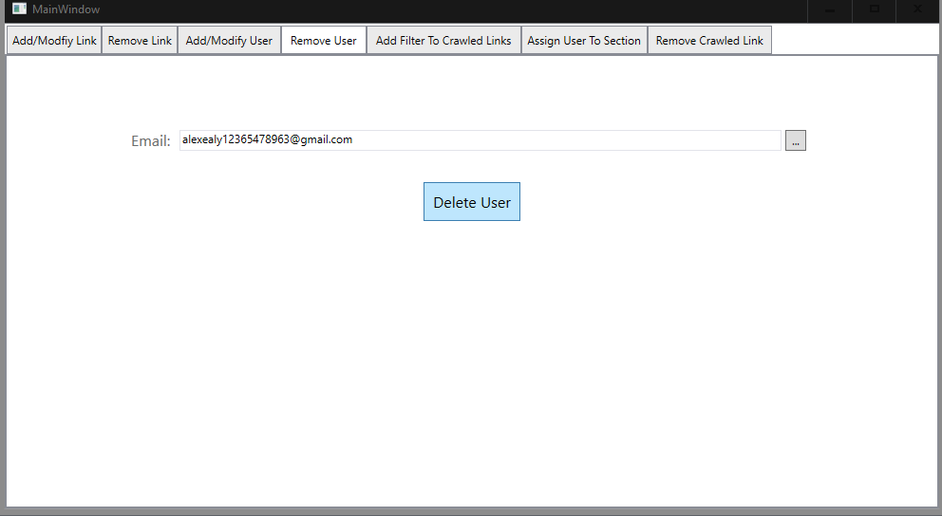

1. Click “Yes” to confirm removing the User

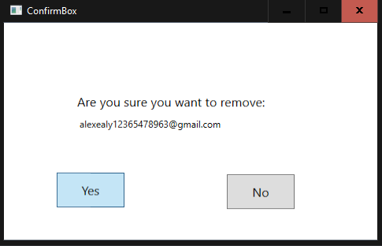

A box will pop up confirming the link was removed

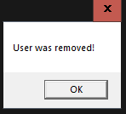

## Removing Users in bulk

Have the DBA as this function is not built in to protect the user.

## Troubleshooting

### User not found

This means the user is not in the system so they cannot be deleted

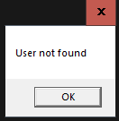

There is no fix, just check the spelling, and if the email is spelt right then the user has been removed.

# Modifying Users

## How to Modify Users

1. Double click on the application

You should be presented with a page that looks like:



1. Go to the “Add/Modfiy” tab

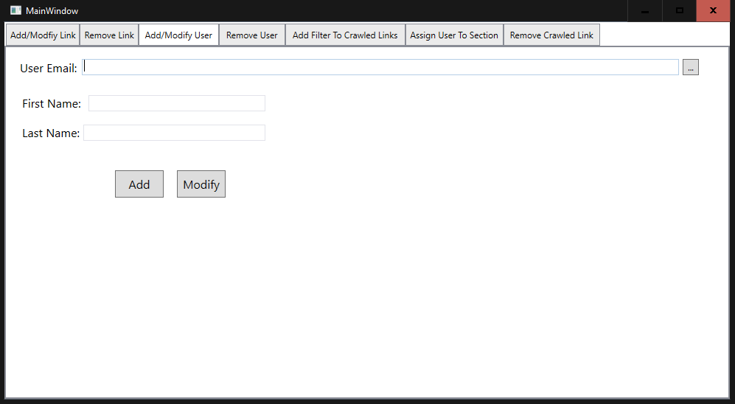

1. Use the search function to find the link to be modified

Note: refer to the Looking up Item section for guidance. It is strongly recommended to use the search function because it will automatically fill in the other boxes with the current values.

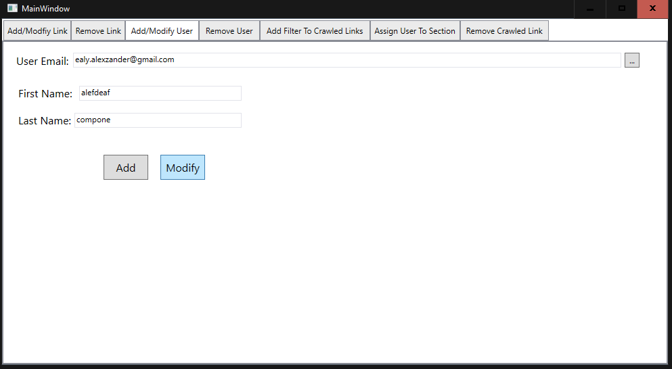

1. Edit any of the textboxes expect the “User Email:” textbox
2. Click “Modify” button

This window will pop up if the user was successfully modified

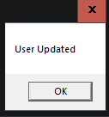

## Troubleshooting

### User not found

The user is not in the system



The fix is to add the user if the users were added

# Users and Categories

## Assigning User to Categories

1. Double click on the application

You should be presented with a page that looks like:



1. Go to the “Assign User To Category” tab

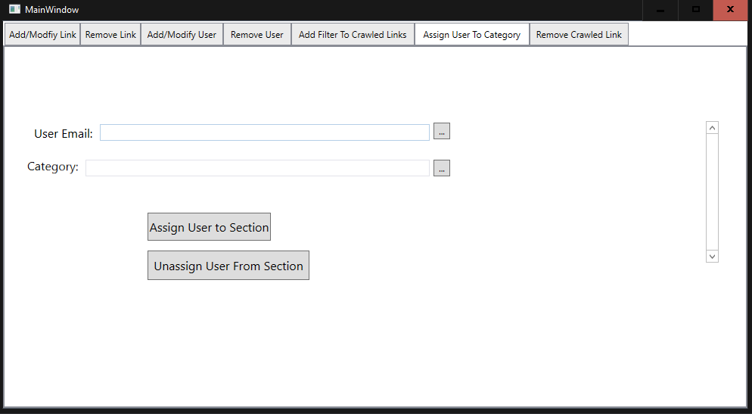

1. Use the search function to fill in both textboxes or enter in an appropriate value for each textbox.

Note: it is strongly recommended to use the search function as it will pull up a list of currently assigned categories and prevent misspelling. For guidance on using the search function refer to Looking up Items section.

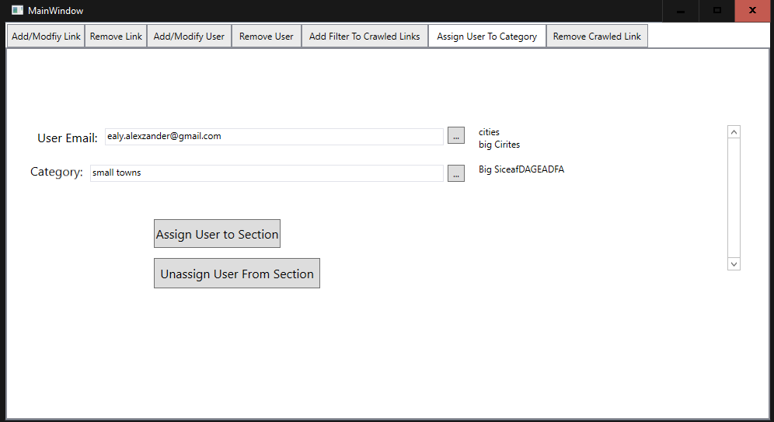

1. Click “Assign user to Section” button

The category should appear in the list to the right of the window

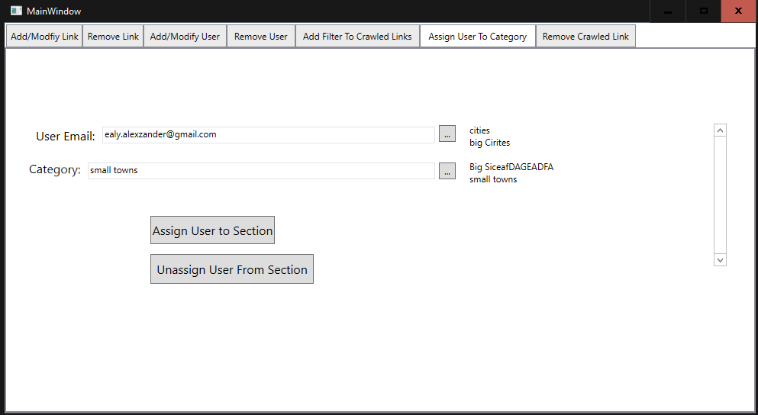

## Unassigning Users from Categories

1. Double click on the application

You should be presented with a page that looks like:



1. Go to the “Assign User To Category” tab



1. Use the search function to fill in both textboxes or enter in an appropriate value for each textbox.

Note: it is strongly recommended to use the search function as it will pull up a list of currently assigned categories and prevent misspelling. For guidance on using the search function refer to Looking up Items section.



1. Click “Unassign user to Section” button

The category should appear in the list to the right of the window



1. The category will be removed from the list on the right of the window

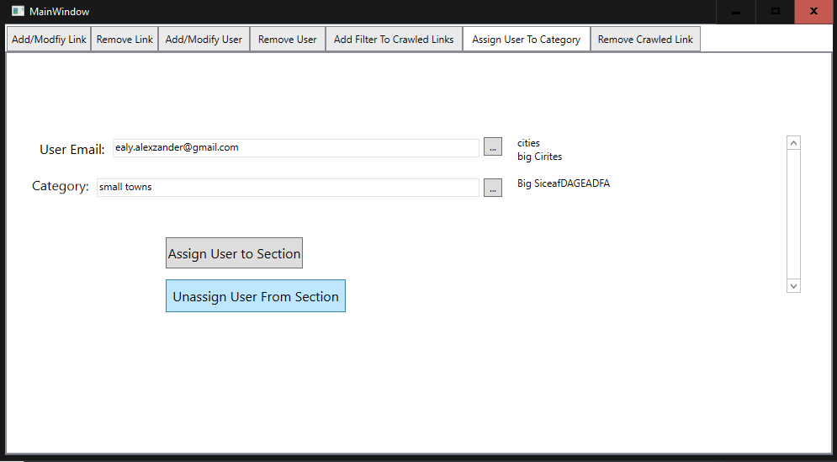

## Troubleshooting

### User not assigned to the section

The user is not assigned to the section so they cannot be unassigned.

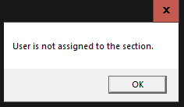

The fix is to either assigned the user, or if the user is not supposed to be assigned then do nothing.

### User already assigned to the section

The user cannot be reassigned to a section they are already assigned to.

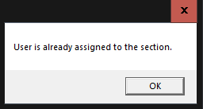

The fix is to do nothing if the user is supposed to be assigned to the section, or unassigned if they are not.

### User not found

This error happens when trying to assign a section to a user who is not in the system

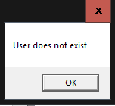

The fix is to add the user to the system using the add user page.

# Looking up Items

This section details the general steps to look up any item that you might want to reuse, or modify such as links, sections, users, and filter.

Click “…” Button.

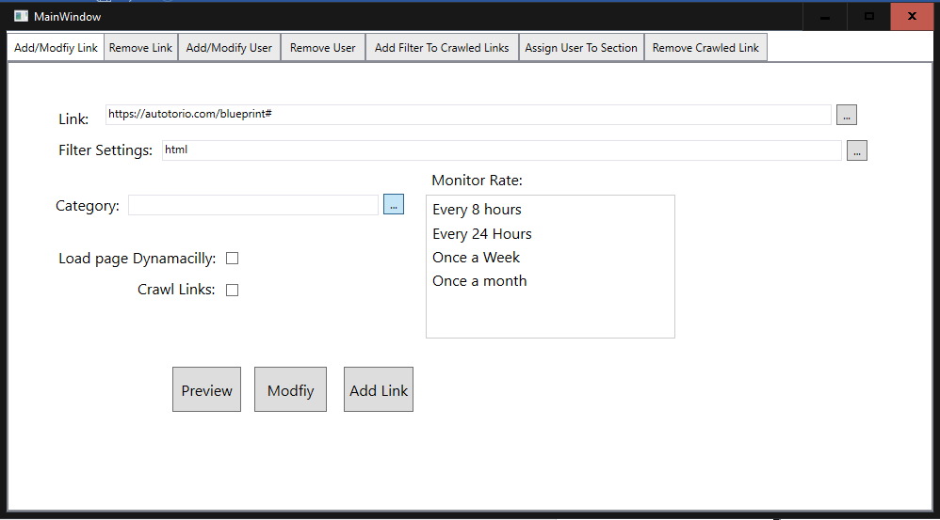

Note: type part of the item to limit results found

A screen similar to what is shown below should pop up.

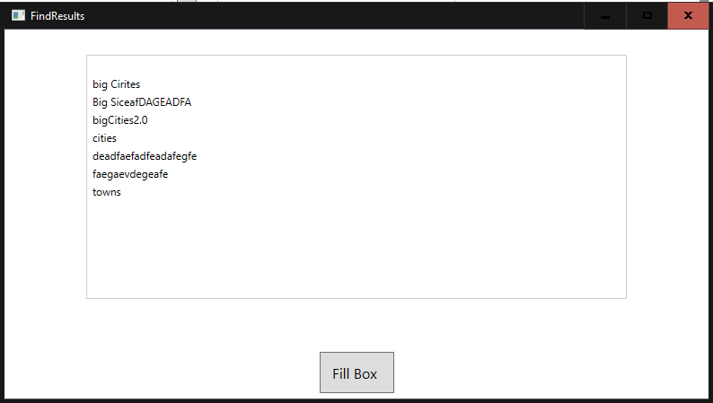

Select the one to use.

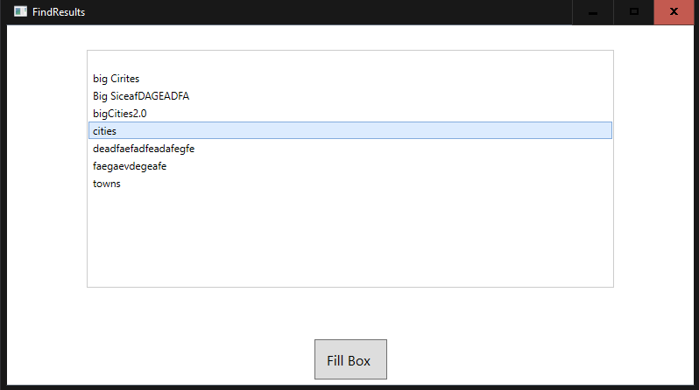

Click the “Fill Box” button.

